# Global Cosmic Calibration — The Ancient Analog System of the Sky

## 1. Introduction: The Sky as the First Clock

Since the dawn of civilization, humanity has looked to the heavens to measure time, navigate, and sustain life. Before magnetic compasses and atomic clocks, ancient cultures used the Sun, Moon, and stars to orient their cities, temples, and pyramids. Through equinox and solstice alignments, they created a universal analog system—a global network of sky-calibrated monuments that remained synchronized with cosmic time.

## 2. The Global Analog Network

Across continents, civilizations such as Egypt, the Maya, China, Anatolia (Göbekli Tepe), and Britain (Stonehenge) each developed their own architectural expressions of the same cosmic method. They aligned structures with the equinox sunrise, solstice sunsets, and key constellations like Orion’s Belt, Pleiades, Cygnus, and Polaris. These alignments were not isolated achievements—they were humanity’s shared blueprint for surviving through time by following the rhythms of the sky.

## 3. Gnomon Geometry and True North

The gnomon—a simple vertical stick casting a shadow—was the earliest precision instrument of civilization. By marking where the shadow aligned perfectly east-west during the equinox, ancient observers determined true north. This geometry became the foundation for every pyramid, temple, and observatory. From Giza to Chichen Itza, from Xi’an to Stonehenge, this solar geometry ensured all monuments resonated with Earth’s axial rotation and the solar cycle.

## 4. Star Calibration Across Civilizations

Each civilization identified key stars that defined its local cosmic reference frame. These alignments connected sky and earth, turning architecture into living instruments of astronomical timekeeping.

|  |  |  |  |
| --- | --- | --- | --- |
| Region | Key Site | Celestial Alignment | Purpose |
| Egypt | Giza Pyramids | Orion’s Belt & Sirius | Tracking Nile floods and spiritual rebirth cycles |
| Maya | Chichen Itza | Pleiades & Zenith Sun | Agricultural planting and equinox festivals |
| China | Xi’an Pyramids | Polaris (North Star) | Imperial alignment and cosmic order |
| Anatolia | Göbekli Tepe | Cygnus & Solar Arc | Ceremonial alignment and seasonal tracking |
| Britain | Stonehenge | Solstitial Sun Rise/Set | Agricultural and ritual synchronization |

## 5. The Cosmic Purpose: Stability and Survival

Civilizations that mastered cosmic synchronization gained a decisive advantage. By tracking equinoxes, solstices, and stellar risings, they could forecast agricultural seasons, predict floods, and prepare for climate cycles. This awareness fostered stability and cultural longevity. Even as some societies fell or migrated, their monuments remained—testimonies of an analog intelligence tuned to the cosmic order.

## 6. Diagrams — Cosmic Calibration Visuals

Diagram 1. Global Alignment Map

Illustrates the Earth’s equatorial band showing the global distribution of ancient sites—Egypt, Maya, China, Anatolia, and Britain—all located along solar or stellar calibration lines that trace the same cosmic geometry.

Diagram 2. Equinox-Solar Calibration Geometry

Shows the Sun’s path at equinox and solstice relative to the horizon and the gnomon shadow line that defines true north. This same geometry allowed each culture to orient its monuments to the cosmos with remarkable precision.

Diagram 3. Pyramid Star Alignments

Depicts the three great star alignments—Orion’s Belt over Giza, Pleiades above Maya temples, and Cygnus over Göbekli Tepe—each forming a cosmic triangle between Earth and the stars.

Diagram 4. True North Gnomon Grid

Shows how equinox shadow tracking defined the east-west line and allowed ancient engineers to mark true north. This method united all ancient civilizations in a single analog framework for cosmic alignment.

© 2025 Gabino Casanova — Global Cosmic Calibration Research

## 7. Equinox Calibration Diagrams

Diagram 1. Equinox Alignment Geometry — Defines east-west horizon using gnomon shadows.

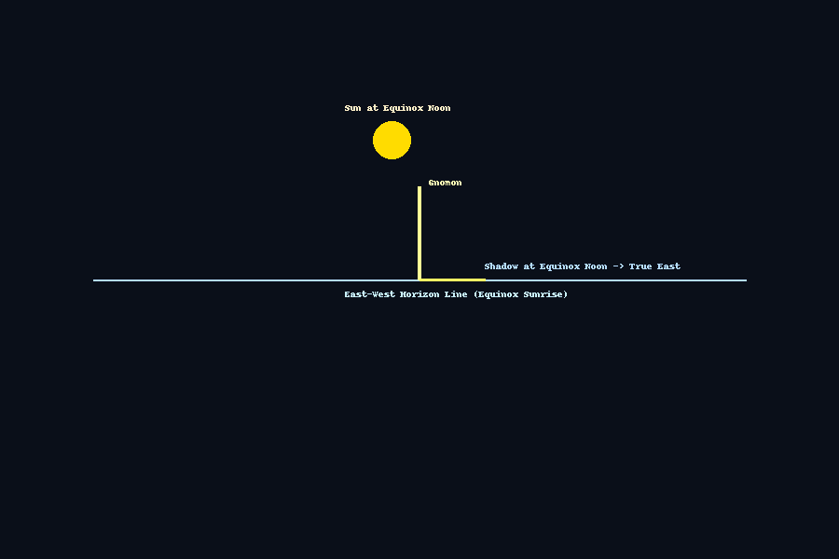

Diagram 2. Global Calendar Synchronization — Civilizations aligned calendars using equinox sun positions.

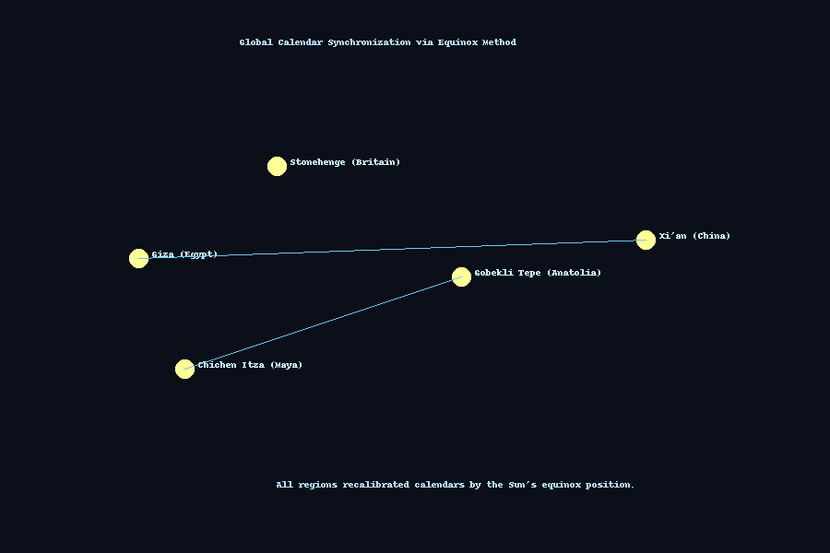

Diagram 3. Solar Arc and True North — Shows solar shift between solstices with equinox calibration line.

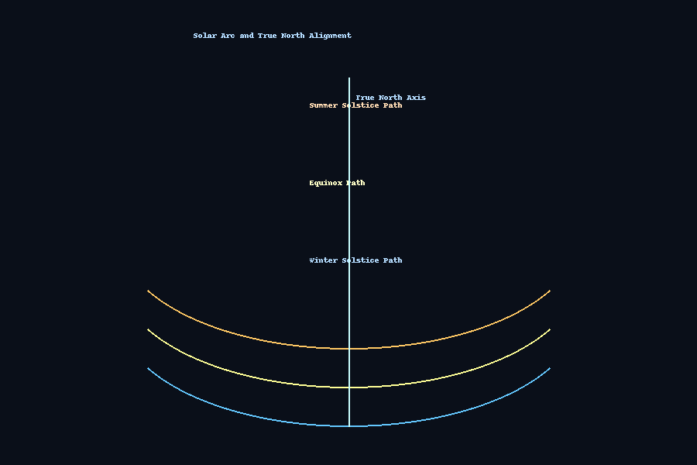

Diagram 4. Analog Calibration Flow — Ancient process to realign temples, calendars, and pyramids with the Sun.

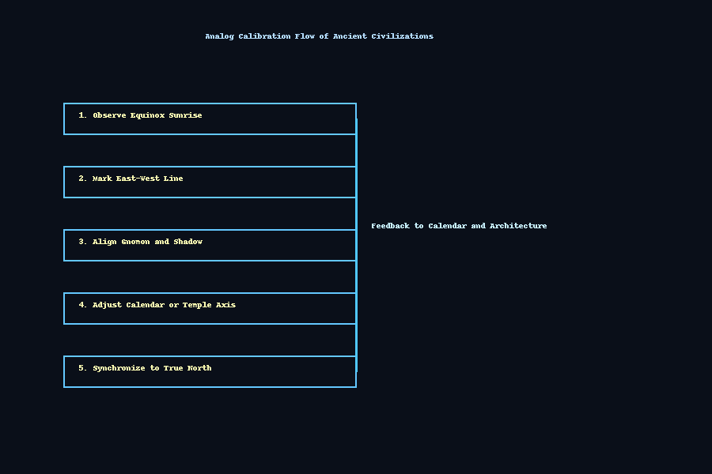

© 2025 Gabino Casanova — Global Cosmic Calibration Research